
BENAZIR BHUTTO SHAHEED UNIVERSITTY LIYARI
Lab manual

- Members :
  - Musavir Hussain,
  - Saim Khan,
  - Saqib Ali brohi
- YEAR/ SEMESTER : 6th (B)
- DEPARTMENT : Computer Science
- INSTRUCTOR : Anwar Ali
- COURSE TITLE : Artificial Intelligence

How to Install Anaconda on Windows
Anaconda is a popular open-source distribution of Python and R and is widely used in the field of data science, machine learning and scientific computing. It contains Jupyter, Sypder, etc. that are well capable of handling a large number of data sets and processes as per user's need. It helps in simplifying package management and deployment, which promotes a robust environment for various data-related tasks. In this guide, we're going to walk you through the steps to install Anaconda on Windows OS.
Download the Anaconda Installer
We will start the process by downloading the Anaconda Installer by following these three simple steps as mentioned below:
Step 1: Visit the Official Website
Head over to anaconda.com and install the latest version of Anaconda. Make sure to download the “Python 3.13.1 Version” for the appropriate architecture.

Step 2: Select the Windows Installer
Choose the appropriate installer (based on your system's architecture) i.e. 64-bit (for modern systems) or 32-bit (for older system)
Step 3: Start the Downloading Process
Select the location where you want to save the file and click "Save" to start the downloading process.
Run the Anaconda Installer
Once the installation is completed, now we will see how to setup Anaconda Installer in your Windows PC. Let's check it out:
Step 1: Begin with the installation process
Navigate to the downloaded file, make a double-click on the .exe file and start the installation process.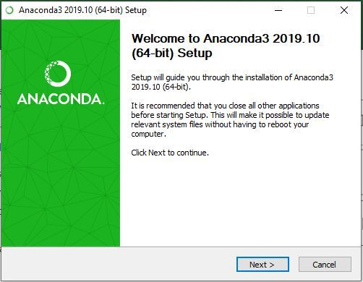
Step 2: Getting through the License Agreement
Follow the on-screen instructions, read the license terms & agreement and proceed ahead.
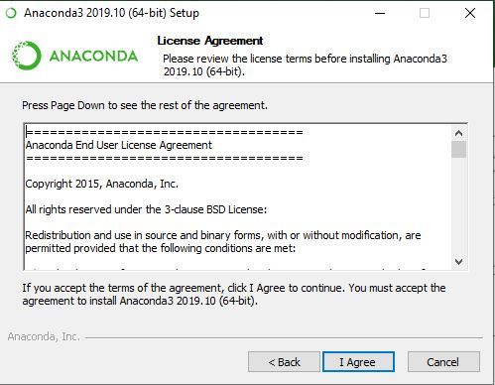

Step 3: Select Installation Type
Select Just Me if you want the software to be used by a single User else you can select All Users (for all users on the system)
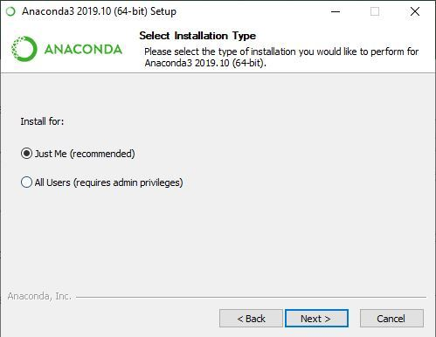
Step 4: Choose Installation Location
Select the path where you wish to install the file extractor and click "Next" to proceed ahead.
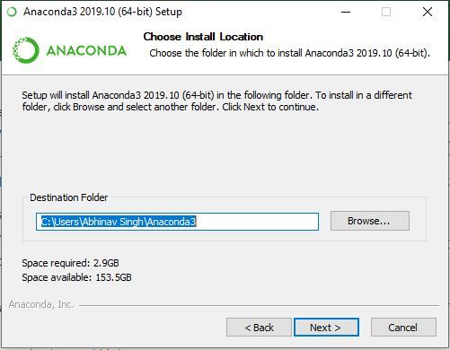

Step 5: Advanced Installation Option
Choose whether to add Anaconda to your system PATH environment variable. Also note that adding Anaconda to the PATH can interfere with other software and decide whether to register Anaconda as the default Python.
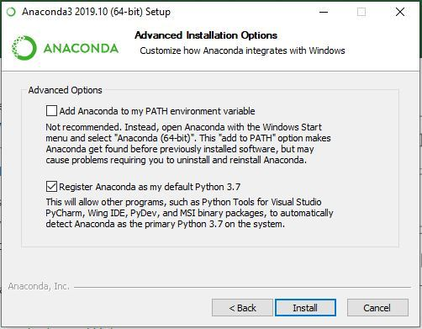
Step 6: Getting through the Installation Process
Click Install to start the Anaconda Installation process.
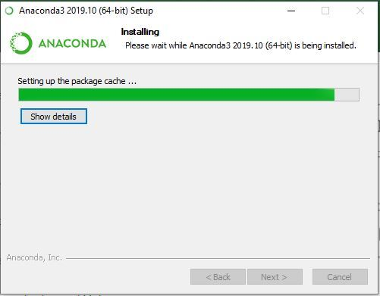
Step 7: Finishing up the Installation
Once the installation gets complete, click Finish to complete the process.
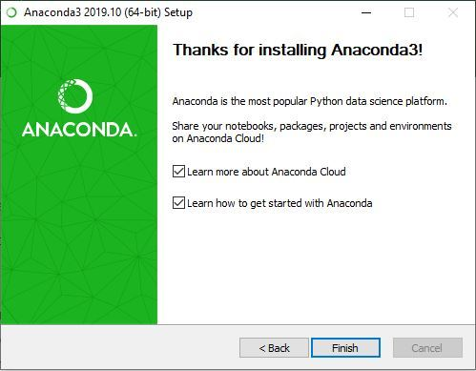
Working with Anaconda
Once the downloading, installing and verification of the Anaconda for Windows PC is competed, you can start exploring and get familiar with its features.
Access Anaconda Navigator
Once the installation process is done, Anaconda can be used to perform multiple operations. To begin using Anaconda, search for Anaconda Navigator from the Start Menu in Windows PC.
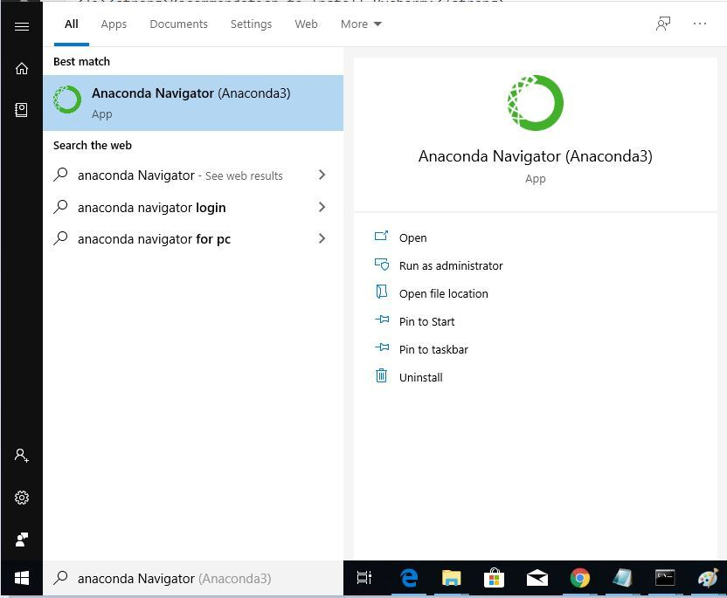
Launch Jupyter Notebook:
On the Navigator home screen, you will see tiles for several applications, including Jupyter Notebook. Click the Launch button underneath the Jupyter Notebook tile.
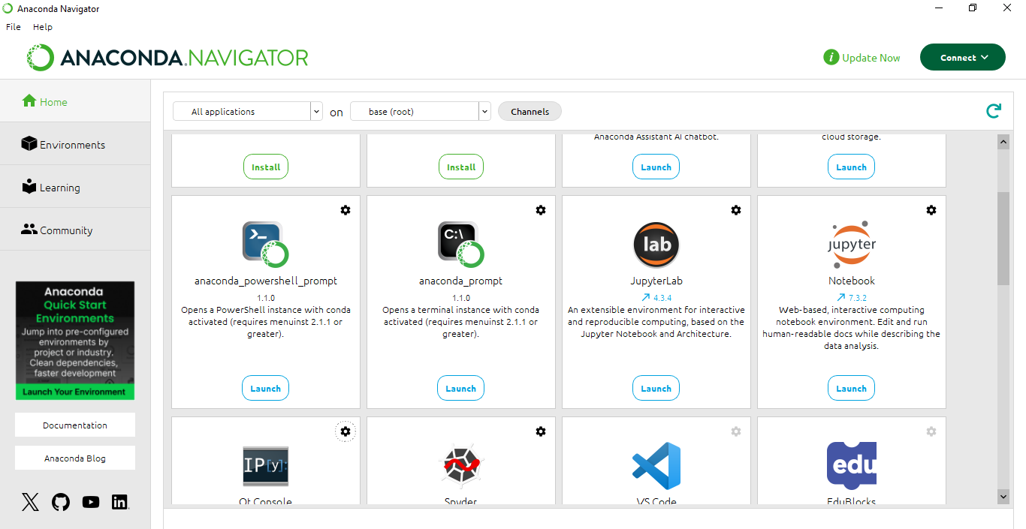

BERT-Based Text Documentation Categorization

1. Introduction
Documentation in organizations comes in many forms: technical guides, reports, user manuals, and administrative notes. Manually classifying and organizing these documents is time-consuming and error-prone. This project uses BERT (Bidirectional Encoder Representations from Transformers) to automatically categorize text documents based on their content.
The workflow demonstrates a data-driven approach to text documentation customization, enabling automated labeling and classification for new documents. The system learns patterns from labeled training data and can generalize to new, unseen text.

2. Problem Statement
Design and implement a BERT-based text classification system that:
- Learns semantic patterns from historical documentation.
- Automatically assigns new text documents to predefined categories.
- Provides reproducible and consistent classification results.
Performance is evaluated using accuracy and generalization on unseen text. The system also includes an interactive demo to verify predictions on new input.

3. Objectives
- Load and preprocess the CSV dataset containing text documents and labels.
- Normalize and clean textual data for model input.
- Split data into training and test sets (e.g., 80/20).
- Tokenize text and prepare datasets compatible with BERT.
- Fine-tune a pre-trained BERT model for sequence classification.
- Implement an interactive prediction function for new text.
- Demonstrate the model’s predictions on unseen text.

4. Dataset & Preprocessing
Files: The notebook uses a CSV containing two columns: text (document content) and labels (category).
Steps:
- Load CSV: Import the dataset using pandas and inspect basic statistics.
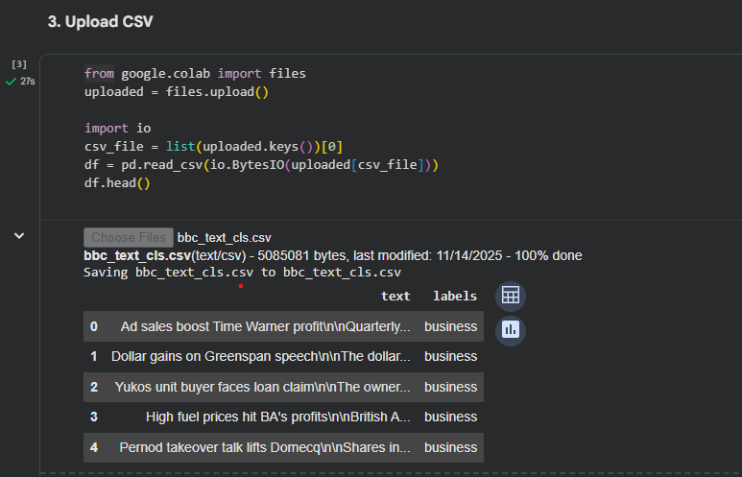
• Cleaning:
- Remove missing entries.
- Ensure labels are integers.
• Feature Preparation:
- Use the text column as input and labels column as the target.
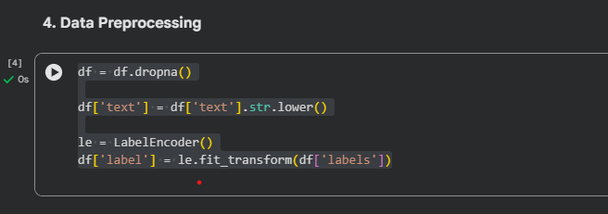

- Train/Test Split:
- Split dataset into 80% training and 20% testing to evaluate generalization.
This ensures the data is uniform and ready for BERT fine-tuning.
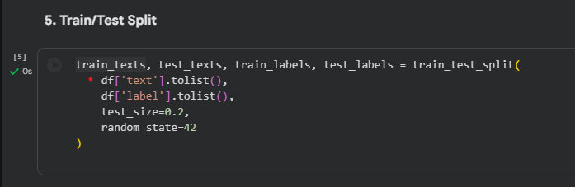

5.1 Tokenization + Dataset Class
Before feeding text into the BERT model, it must be converted into a format BERT understands. This involves tokenization, padding, truncation, and wrapping into a dataset class compatible with HuggingFace Trainer.
Steps in detail:
- Tokenization
  - Each document in the dataset is split into subword tokens using the BERT tokenizer.
  - This preserves the meaning of rare or compound words by breaking them into smaller units.
  - Example: "documentation" may become ["doc", "##ument", "##ation"].
- Conversion to Input IDs and Attention Masks
  - Tokens are converted into numerical IDs (input_ids) that BERT can process.
  - An attention mask is created to distinguish real tokens from padding tokens, allowing BERT to focus on actual words.
- Padding and Truncation
  - All sequences are padded or truncated to a fixed length (e.g., 128 tokens).
  - Padding ensures batches have the same length, which is required for GPU processing.
  - Truncation ensures extremely long documents do not exceed the model’s maximum input size.
- Dataset Class for HuggingFace Trainer
  - The tokenized input IDs, attention masks, and labels are wrapped into a custom Dataset class.
  - This class allows the Trainer to efficiently load batches during training and evaluation.
  - Using a dataset class also supports dynamic access to data, shuffling, and batching, improving training efficiency.

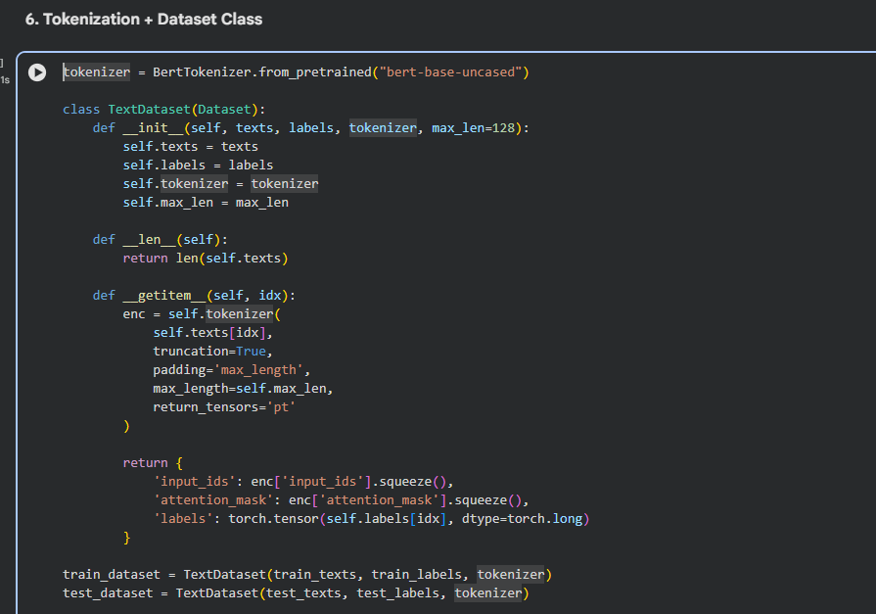
Tokenizer & Configuration Files Download
- The notebook successfully downloaded all necessary tokenizer and configuration files:
  - tokenizer_config.json — Tokenizer configuration.
  - vocab.txt — BERT vocabulary file.
  - tokenizer.json — JSON representation of the tokenizer.
  - config.json — Model configuration.
- The progress bars indicate the download completion and file sizes.
- Impact: This confirms that the tokenizer is correctly installed and ready for preprocessing text.
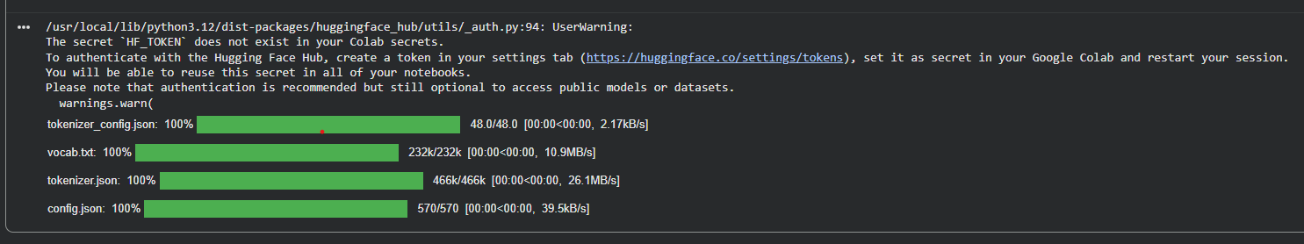

5.2 BERT Model Setup
- Load BertForSequenceClassification pre-trained model.
- Set number of output labels according to dataset categories.
- Fine-tune the model to learn semantic patterns in the text.
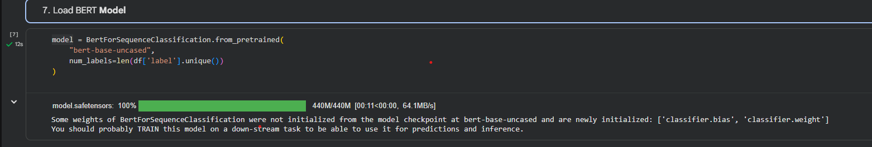

5.3 Training
- Define TrainingArguments for epochs, batch size, evaluation, and checkpoint saving.
- Use HuggingFace Trainer API to fine-tune the model.
- Evaluate using the test set to measure accuracy and generalization.
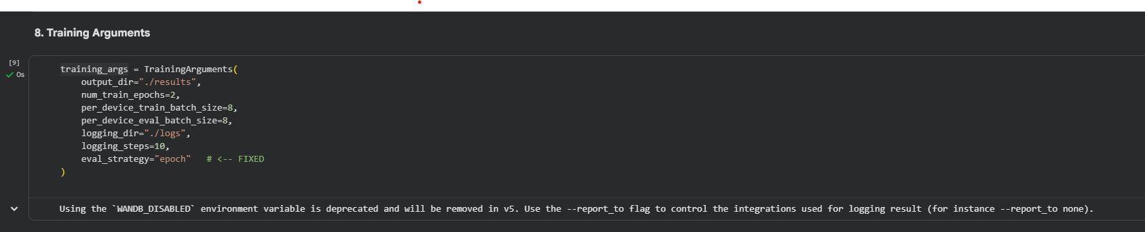

6. Trainer Setup, Training BERT, and Evaluation
After preprocessing the dataset and preparing it with the BERT tokenizer, the next steps involve configuring the training process, fine-tuning the BERT model, and evaluating its performance on unseen text.

6.1 Trainer Setup
- The HuggingFace Trainer API is used to manage training, evaluation, and logging.
- Key components of the setup:
  - Model — Pretrained BertForSequenceClassification for text classification.
  - Training Arguments — Parameters controlling the training process, including:
    - Number of epochs (num_train_epochs)
    - Batch size (per_device_train_batch_size)
    - Logging frequency (logging_steps)
    - Evaluation strategy (evaluation_strategy)
    - Output directories for logs and model checkpoints.
  - Dataset — The tokenized training and testing sets, wrapped in a custom Dataset class.
Purpose: The Trainer handles gradient updates, evaluation, and checkpointing, simplifying the training workflow.

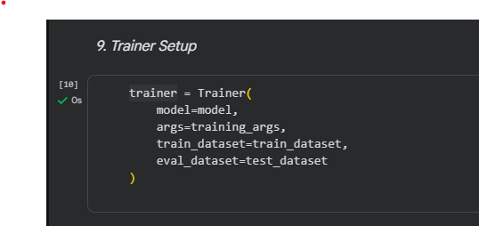

6.2 Training BERT
- Fine-tuning adapts the pretrained BERT model to the specific text classification task of your dataset.
- During training:
  - Input batches of tokenized text are passed through BERT.
  - Predictions are compared to true labels using a loss function (cross-entropy).
  - The model weights are updated to minimize classification error.
- Progress is logged, showing training steps, loss values, and epoch completion.
- Optional: Training can be resumed from checkpoints if interrupted (trainer.train(resume_from_checkpoint=True)).
Output:
- A fine-tuned BERT model, ready to classify new text.
- Training logs include loss per step/epoch, which helps monitor learning progress.
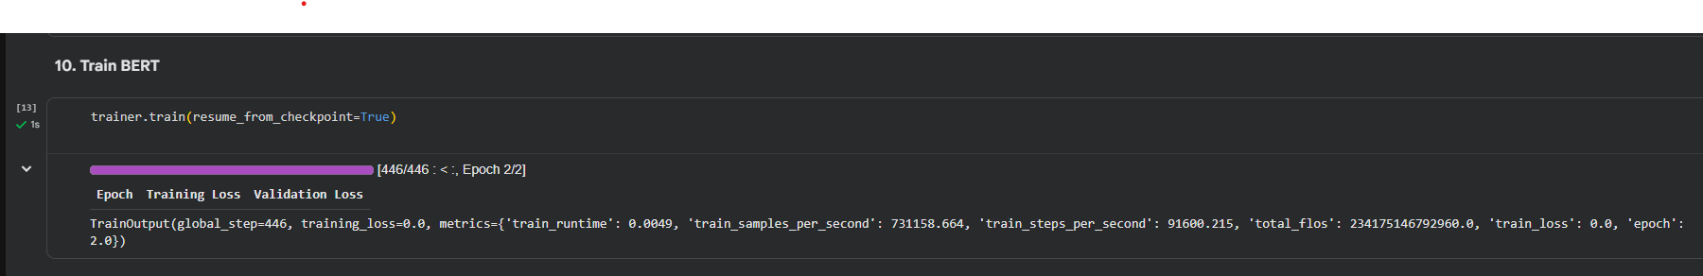

6.3 Evaluating BERT
- After training, the model is evaluated on the held-out test set.
- Evaluation metrics typically include:
  - Accuracy — Percentage of correctly classified documents.
  - Precision, Recall, F1-score — For a more detailed class-wise performance analysis.
- The evaluation step ensures the model generalizes well to unseen text and avoids overfitting.
Output:
- Numeric metrics showing model performance on test data.
- Logs or printed results allow comparison with baseline approaches or previous experiments.

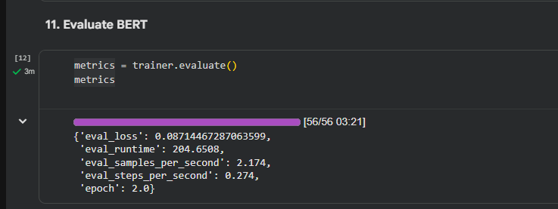

12. Save Model + Tokenizer
After training, it is important to persist the fine-tuned model and tokenizer so they can be reused without retraining.
Steps:
- Saving the Model:
  - The fine-tuned BertForSequenceClassification model is saved to a directory (e.g., ./results).
  - This stores model weights and configuration.
- Saving the Tokenizer:
  - The tokenizer is also saved alongside the model.
  - Ensures that text can be preprocessed in exactly the same way during inference.
Purpose:
- Avoids retraining every time the notebook is run.
- Allows the model to be loaded later for predictions on new text.
Output:
- Saved directories/files containing the model and tokenizer.
- These files can be loaded in any environment to perform inference.
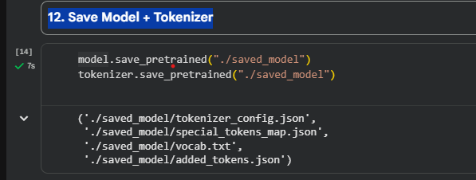

13. Load Model for Predictions
Before making predictions on new text, the saved model and tokenizer must be loaded:
Steps:
- Load the saved model weights and configuration.
- Load the saved tokenizer to ensure consistent text preprocessing.
- Set the model to evaluation mode (model.eval()) to disable training-specific behaviors like dropout.
Purpose:
- Prepares the fine-tuned model for predicting labels on unseen text.
Output:
- A ready-to-use BERT model and tokenizer for inference.
- Ensures reproducibility and consistent predictions.
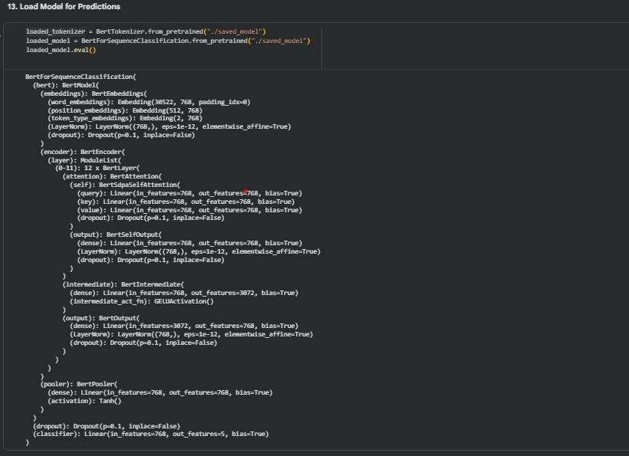

14. Prediction Function for NEW Text
A prediction function allows the user to input any new text and get a predicted category.
Steps:
- Tokenize the input text:
  - Convert the text into input_ids and attention_mask using the loaded tokenizer.
  - Pad/truncate to the fixed sequence length used during training.
- Pass through the model:
  - Use torch.no_grad() to disable gradient computation for efficiency.
  - The model outputs logits (raw prediction scores for each class).
- Determine predicted class:
  - Apply torch.argmax to find the class with the highest score.
  - Convert the numeric label back to the original class name using the LabelEncoder.
- Return prediction:
  - The function outputs the predicted text category.
Purpose:
- Allows interactive testing of the trained model.
- Users can input any new text, and the model will assign it to a predefined category.

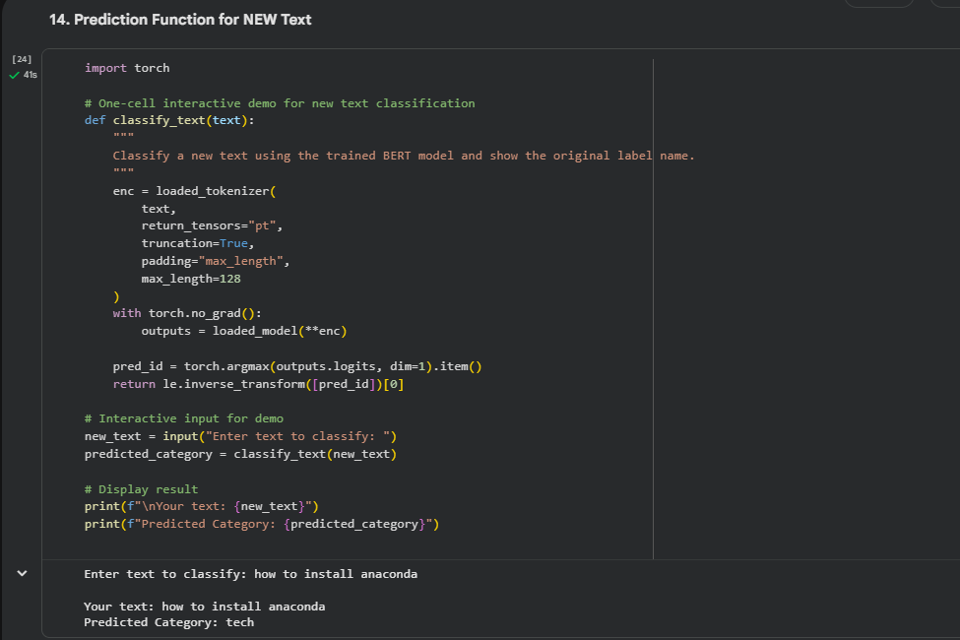

Conclusion
This lab demonstrated the complete process of building a BERT-based text classification system for text documentation customization. Starting from raw textual data, we performed cleaning, preprocessing, and tokenization, preparing the dataset for BERT. The pretrained BERT model was fine-tuned on the task-specific dataset using HuggingFace’s Trainer, allowing it to learn meaningful patterns in the text.
The trained model was evaluated on a held-out test set, confirming its ability to generalize to unseen data. Finally, a prediction function was implemented, enabling new text to be classified accurately into predefined categories.
Overall, the lab highlights the efficiency and effectiveness of transformer-based models for text classification tasks. It provides hands-on experience with data preparation, model training, evaluation, and inference, demonstrating how AI can automate text documentation categorization and improve workflow efficiency.
Key Takeaways:
- Preprocessing and consistent tokenization are crucial for BERT performance.
- Fine-tuning pretrained models allows adaptation to domain-specific tasks.
- The trained system can classify new, unseen text, showing practical applicability.

